PRESS RELEASE

Tuesday 11 June 2019 – FOR IMMEDIATE RELEASE

BADHAM PHARMACY TO OPEN THIRD PHARMACY IN BISHOPS CLEEVE

Badham Pharmacy are pleased to announce that after a seven year long fight with NHS England they have been awarded a third pharmacy contract in Bishops Cleeve. The new pharmacy will be located within Cleevelands Medical Centre and will open in August 2019. Cleevelands Medical Centre is a purpose built healthcare centre, and an amalgamation of Greyholme and Sevenposts Surgeries who moved there in January of this year.

Peter Badham, Managing Director of Badham Pharmacy said;
“My father opened our branch at 23 Church Road, Bishops Cleeve exactly 65 years ago to provide pharmacy services to local residents. Since that time Bishops Cleeve has grown from a village into a town, with over 18,000 people estimated to be living in Bishops Cleeve and the surrounding villages by next year. The Cleevelands housing development, to the North of Bishops Cleeve, is where the new surgery is located but also has poor public transport. We are delighted to have now been granted permission to offer a range of pharmacy and NHS services from this location to all patients and residents”.

Dr Marson, GP at Cleevelands Medical Centre, attended the NHS England hearing that finally decided the outcome of the pharmacy contract application. At the meeting Dr Marson said;
“They had always planned to have a pharmacy on site”.

Councillor Andy Walker from Bishop's Cleeve Parish Council also attending the NHS England hearing said;
“The size and speed of the population increase had put a strain on the infrastructure. Many residents in the town were very elderly… and there are many parking restrictions in place. The general consensus amongst councillors was that it was madness that there was no pharmacy at the medical centre.”

Despite adverse trading conditions for pharmacy currently, Badham Pharmacy strives to provide exceptional service and healthcare provision to residents across Gloucestershire and Bristol. This is demonstrated by the pharmacy at 23 Church Road Bishops Cleeve providing 65 years of continuous service. The pharmacy has been open every day of the year since 1954 – including every Christmas Day, Boxing Day and New Years Day.

More information will be made available to the public in the coming weeks. Local residents are advised to keep an eye on the company website for further information.

ENDS

For more information please contact Peter Badham pss.badham@badhampharmacy.co.uk or phone
01242 676 569.
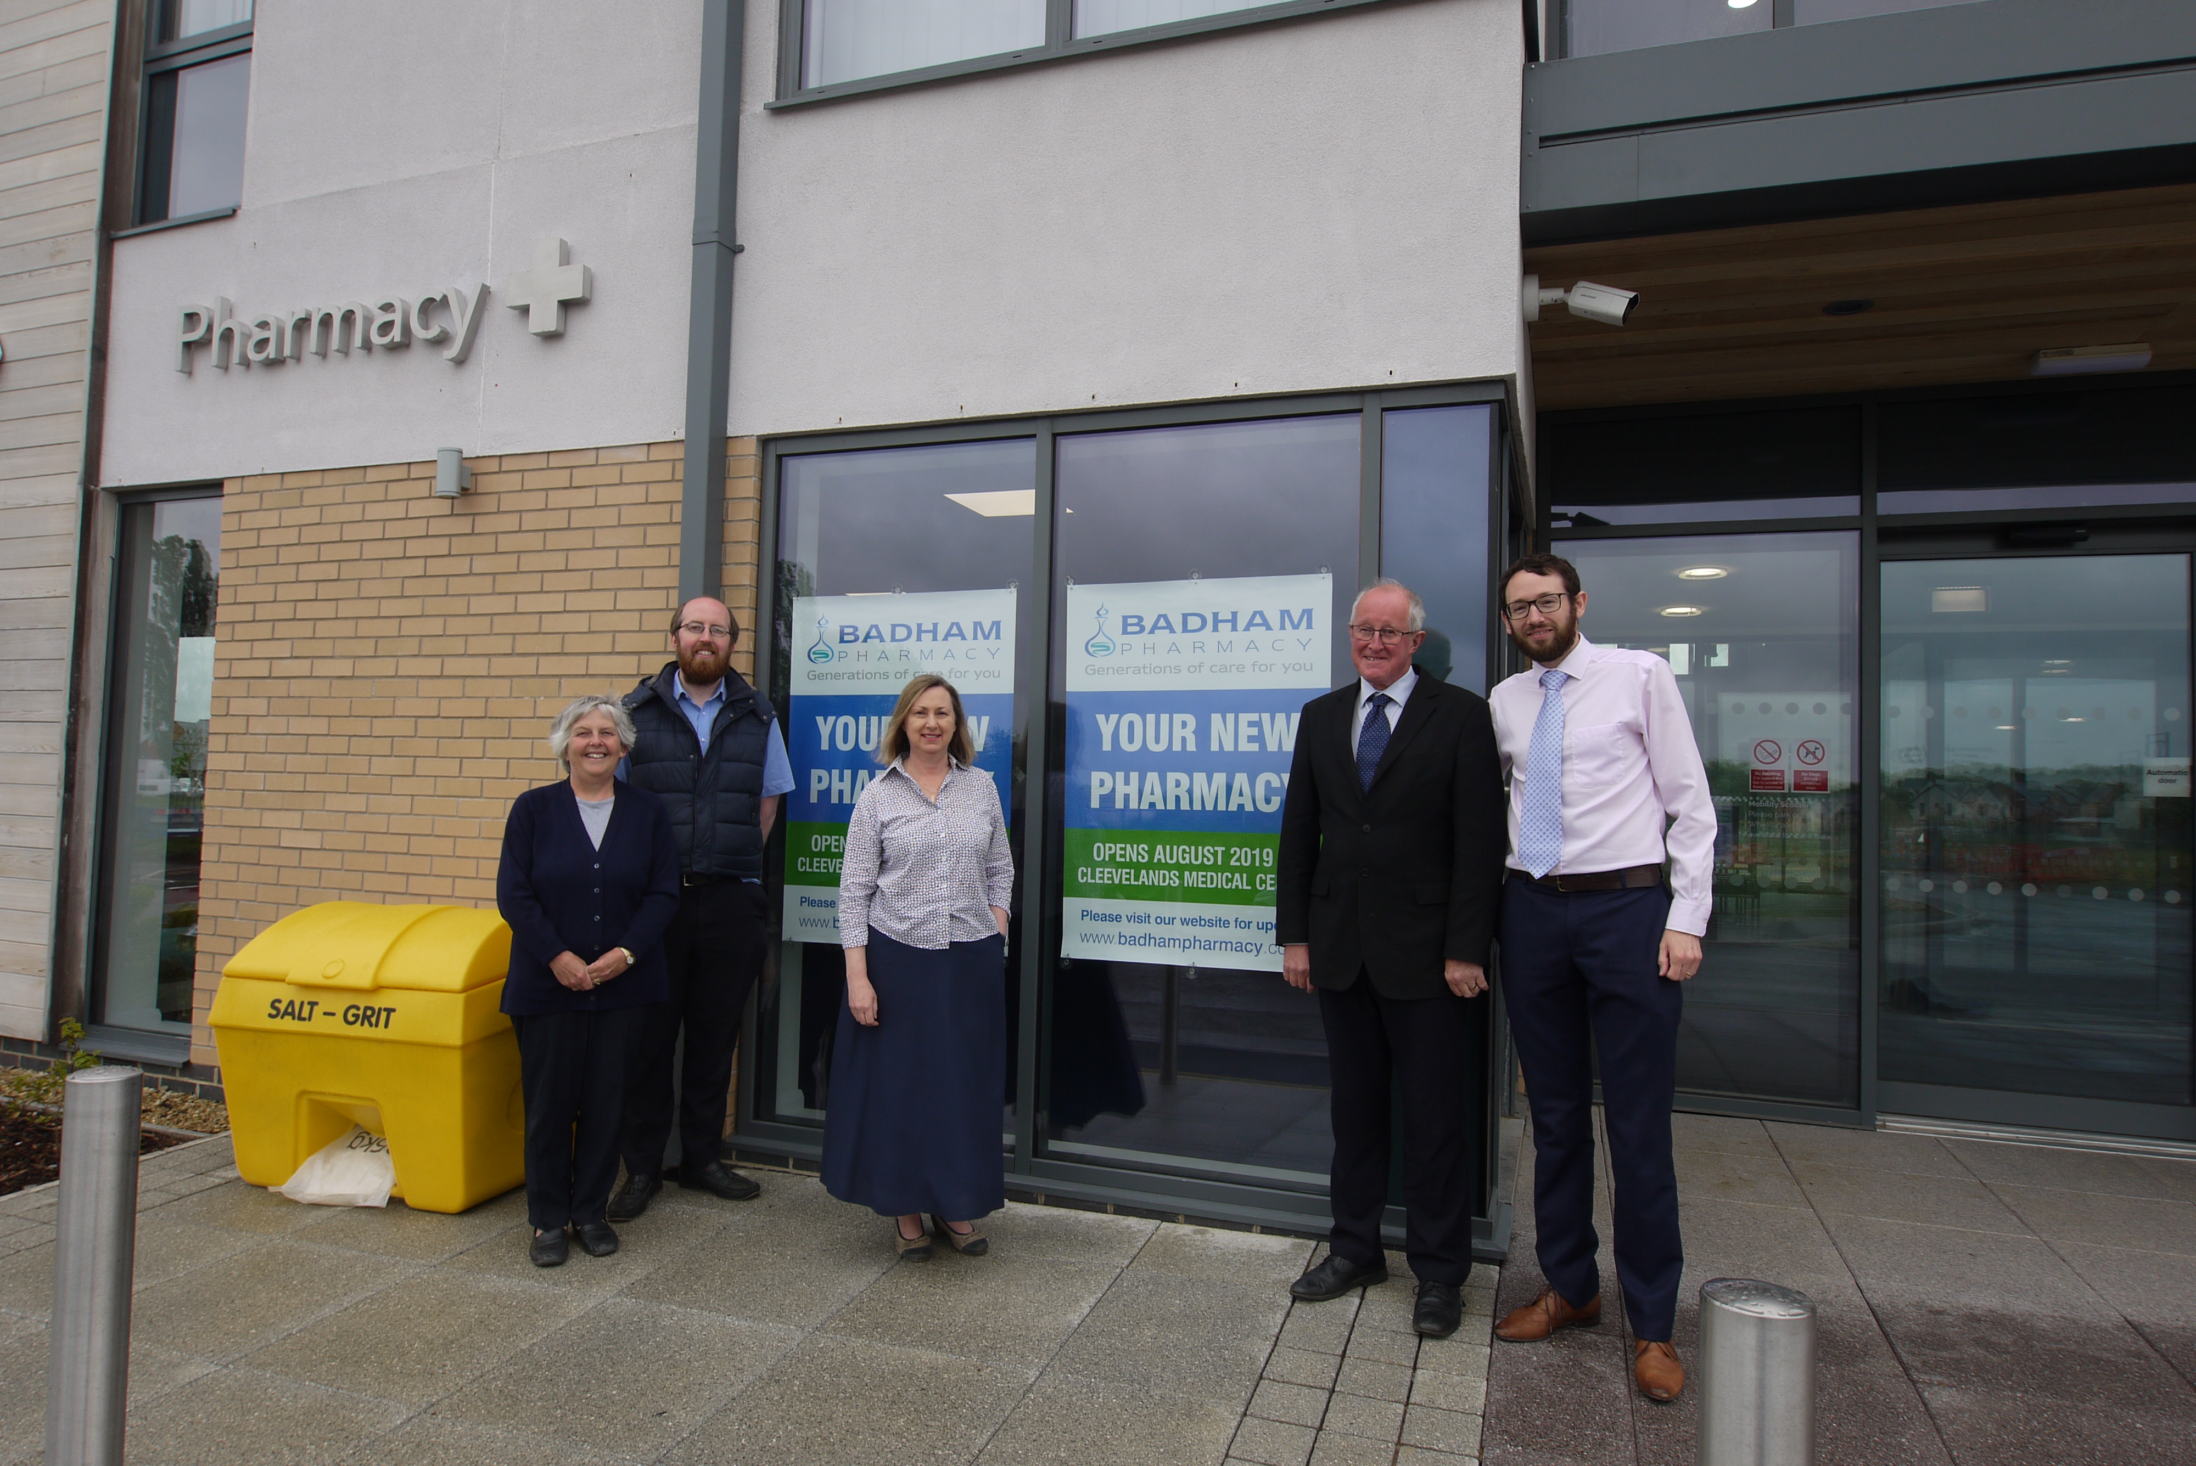
Photo: The pharmacy premises at Cleevelands Medical Centre, Bishops Cleeve

Left to right:
Linda Badham (Director, Badham Pharmacy)
Charles Badham (Director, Badham Pharmacy)
Dr Diane Marsen (Partner, Cleevelands Medical Centre)
Peter Badham (Managing Director and Superintendent Pharmacist, Badham Pharmacy)
Stephen Ireland (Non-executive Director, Badham Pharmacy)

About Badham Pharmacy
- Badham Pharmacy is an award-winning independent pharmacy chain headquartered in Cheltenham, Gloucestershire.
- Founded in 1940 by Richard G. Badham, the family business is now managed by second generation Peter, his wife Lin and their son Charles.
- The pharmacies offer a full range of NHS pharmacy services and were the first company in the area to offer a free prescription collection and delivery service.
- Badham Pharmacy employs over 185 staff across twenty pharmacies and a mobility aids centre.
- The company dispenses 169,000 prescription items a month (and growing) to patients across Gloucestershire and Bristol.
- The company prides itself in its commitment to staff development and outstanding customer service.
- Badham Pharmacy continues to achieve year on year profitable growth so as to realise the company vision to develop Badham Pharmacy as the largest independent chain of pharmacies, differentiated by its service excellence in the area.
- In May 2016 the company successfully acquired Stow Pharmacy.
- In May 2017 the company expanded further into the Cotswolds when it opened a new pharmacy in Upper Rissington.
- In April 2018 the company acquired CSPC Pharmacy Ltd comprising the pharmacies at Aspen Medical Centre and 12 London Road, Gloucester.
- In 2018 Badham Pharmacy won Pharmacy Innovation of the Year at the Independent Pharmacy Awards for their work on the staff Flu Vaccination Programme at Gloucestershire County Council.

