PRESS RELEASE

Thursday 22 November 2018 – FOR IMMEDIATE RELEASE

BADHAM PHARMACY WIN PHARMACY INNOVATION OF THE YEAR At the INDEPENDENT PHARMACY AWARDS 2018

Badham Pharmacy have won Pharmacy Innovation of the Year at the Independent Pharmacy Awards 2018 for their work on the staff Flu Vaccination Programme at Gloucestershire County Council.

The winners of this year's Independent Pharmacy Awards were announced at a celebratory luncheon at the House of Commons.

The judges said that Badham’s work with the county council was a great example of joined up working between an independent pharmacy business and the local council.

Last winter almost 1500 Gloucestershire County Council staff were vaccinated against the flu virus by Badham Pharmacy. This year’s vaccination programme is well underway; last years numbers have already been surpassed with over 1600 council staff vaccinated through clinics and at Badham Pharmacy sites.

Peter Badham, Managing Director and Superintendent Pharmacist of Badham Pharmacy said;

“Badham Pharmacy have been working in partnership with the GCC to improve the health and wellbeing of local communities. As a company we are determined to provide innovative services not only in our pharmacies, but also to the wider population. We are absolutely thrilled to win this award.

“Flu is a major source of illness, and premature death in our county every year, so stopping its spread, particularly to the most vulnerable, is very important.”

Cllr Tim Harman, cabinet member for public health at Gloucestershire County Council added;

“It’s great to hear that our work with Badham Pharmacy has been recognised at the Independent Pharmacy Awards 2018. Our partnership with Badham’s continues to go from strength to strength.

“Not only does the programme help keep our own workforce fit and well through the winter months, but it also helps to protect the people they work with on a day-today basis and the wider community against the flu virus.”

Badham Pharmacy continue to offer a flu vaccination service from its pharmacies across Gloucestershire, an NHS funded service that is free to eligible patients. They also provide a private flu vaccination service to individuals and businesses across the region. Anyone wishing to receive a flu vaccination are urged to contact their nearest branch to check their suitability and eligibility.

ENDS

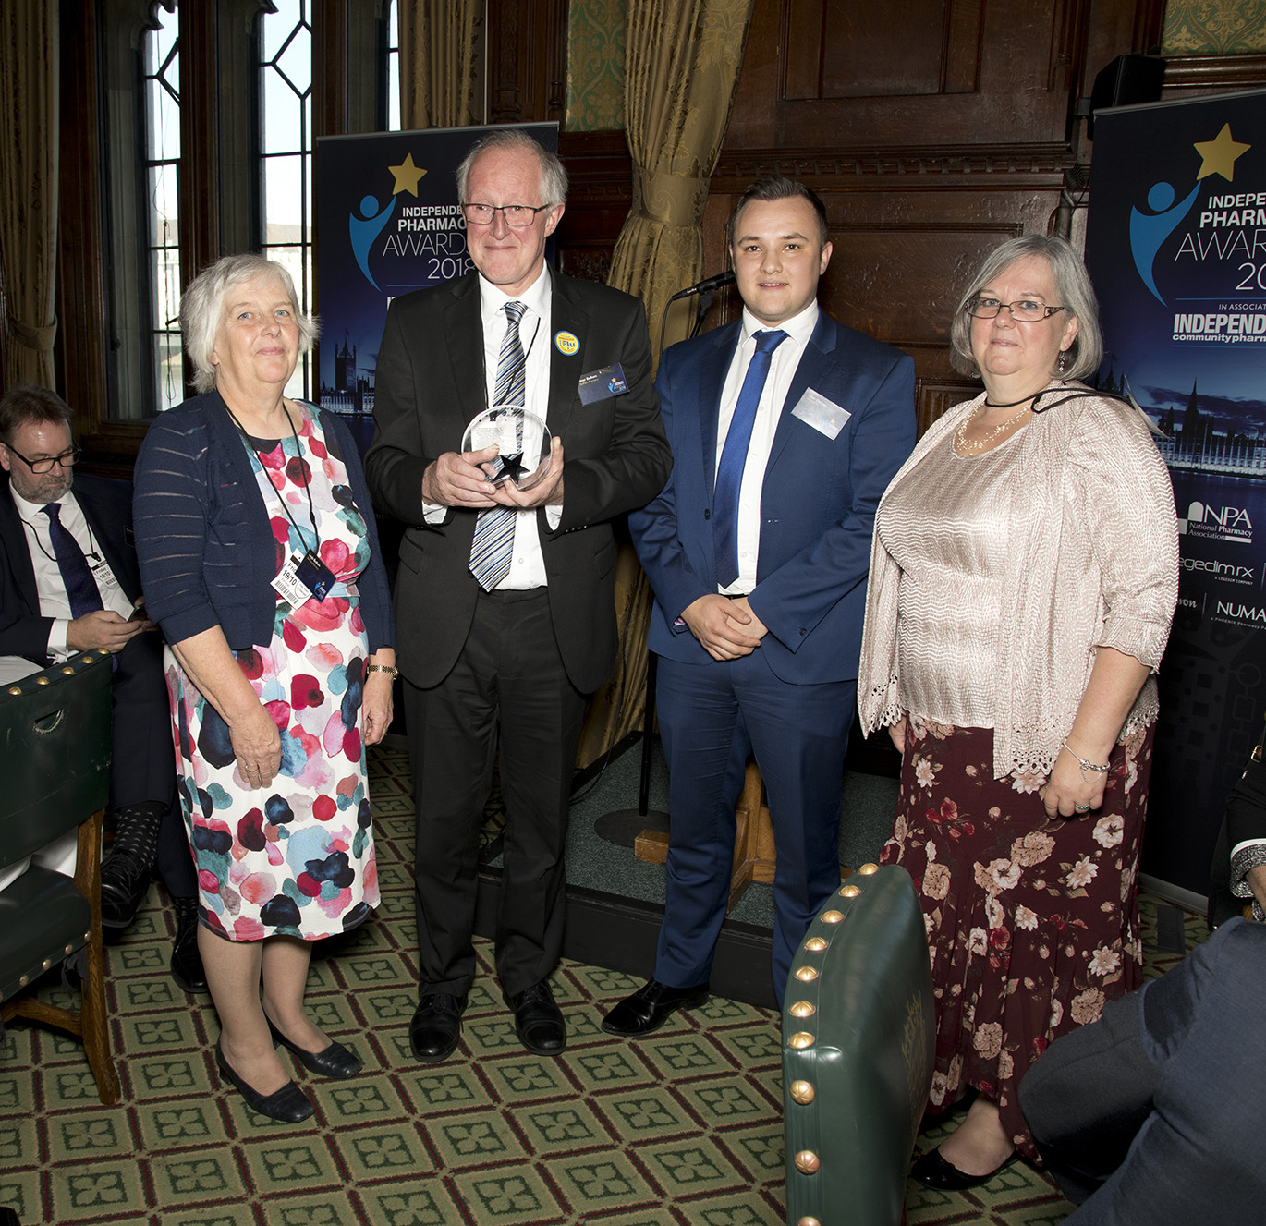
For more information please contact Cathy Morgan FCMA CGMA (CFO) c.morgan@badhampharmacy.co.uk 01242 898710 or Peter Badham pss.badham@badhampharmacy.co.uk 01242 676569.

Photo: Receiving the Innovation Award at the House of Commons
Left to right:
Linda Badham (Director, Badham Pharmacy),
Peter Badham (Managing Director & Superintendent Pharmacist, Badham Pharmacy),
Adam Dennett (Cegedim Rx) who presented the award,
Catherine Morgan (Badham Pharmacy Chief Finance Officer).

About Badham Pharmacy
- Badham Pharmacy is an award-winning independent pharmacy chain headquartered in Cheltenham, Gloucestershire.
- Founded in 1940 by Richard G. Badham, the family business is now managed by second generation Peter, his wife Lin and their son Charles.
- The pharmacies offer a full range of NHS pharmacy services and were the first company in the area to offer a free prescription collection and delivery service.
- Badham Pharmacy now employs over 185 staff across twenty pharmacies and a mobility aids centre.
- The company dispenses 169,000 prescription items a month (and growing) to patients across Gloucestershire and Bristol.
- The company prides itself in its commitment to staff development and outstanding customer service.
- Badham Pharmacy continues to achieve year on year profitable growth so as to realise the company vision to develop Badham Pharmacy as the largest independent chain of pharmacies, differentiated by its service excellence in the area.
- The company was awarded Family Business of the Year 2015 by the Gloucestershire Business Awards and Cotswold Life Magazine.
- In May 2016 the company successfully acquired Stow Pharmacy.
- In May 2017 the company expanded further into the Cotswolds when it opened a new pharmacy in Upper Rissington.
- In April 2018 the company acquired CSPC Pharmacy Ltd comprising the pharmacies at Aspen Medical Centre and 12 London Road, Gloucester.

